Orator’s Report
on the 9th 10th & 11th Degree
Elu of the 9, 15, and 12
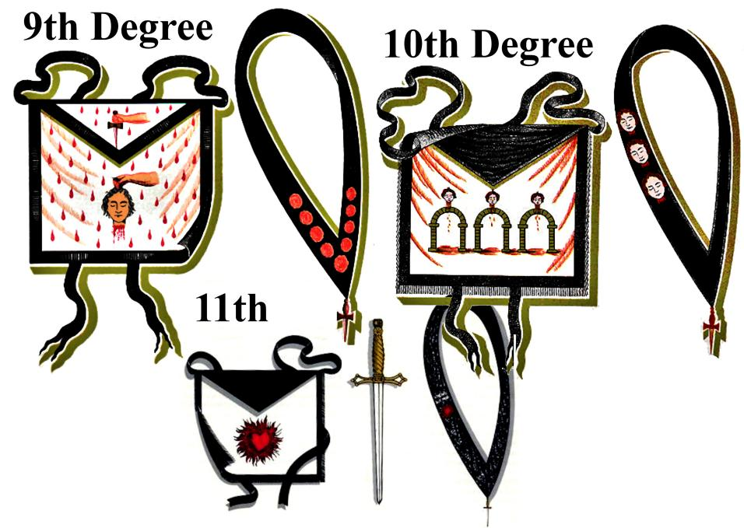
May 18, 2021

The aprons of the Degrees are white with black trim and include the heads of the assassins (9-10), a flaming heart (11th).The jewel is a dagger.

Bremerton Valley of the Scottish Rite

The Legend
The 9th degree Elu of the 12, 10th degree Elu of the 15, and 11th degree Elu of the 12 continue the Hiramic Legend that follows after Master Hiram Abiff's death and dramatize the capture, trials and fates of the three retched assassins of the Master.
The Settings
The 9th and 10th scenes 1-2 are near a cave in the Judean hills outside of Jerusalem. Scenes 3-4 are in the audience chamber of King Solomon. King Solomon sits in the East. The 11th degree setting represents King Solomon's Chamber of Audiences; Zabud, a judge in Israel, is seated in the East. The Candidate represents Ben Dekar of the Elu of the twelve.
The Ritual
In the 9th Degree, King Solomon immediately selects nine men, one of whom, Yehú-Aber, is represented by the candidate, to bring back the murderers alive, warning: “Let us not allow Law and Justice to be deceived ”. In the cave they see one of the assassins asleep. The candidate is ordered to arm himself and if the man awakens, hit him on the head and heart. The assassin places his left hand on his head and then on his heart and falls dead at the hands of Yehu-Aber. The assassin's head is severed and all return to Jerusalem.
The 10th degree, Elu of the Fifteen, relates to how the Master Hiram's two remaining assassins were captured. Though they have fled from Jerusalem into Gath, their identity is nonetheless discovered. King Solomon selects six Perfect Masters by lot to accompany the nine Elu into Gath (in southern Israel, the site is known today as Tell es-Safi) to capture and return the miscreants.
In the 11th degree, 12 Elu , dedicated to truth, are selected to sit in judgement of the assassins who are tried, convicted and executed. The heads of all three are placed upon the gates of the city as a deterrent to crime. Thus are the demands of justice satisfied.
No sooner has King Solomon dispensed with the demands of justice in the matter of the death of Hiram Abiff than he must turn his wisdom upon another problem in his kingdom: there is corruption in the collection of taxes and many complaints have reached the ears of the king's chancellor who dutifully reports them. King Solomon selects twelve from the fifteen Elu and appoints each over a province with the solemn charge to administer fairly and protect the people from political abuse.
The Lesson
The assassin captured in the 9th degree represents ignorance, the two remaining assassins are fit symbols of ambition and fanaticism. Taken together, these three vices are the chief enemies of political freedom. Ignorance impedes, ambition denies, and fanaticism imposes. Ignorance impedes the cause of human progress; Ambition denies equal opportunity in political affairs and fathers tyranny or despotism; Fanaticism imposes, by force or otherwise, beliefs upon those who do not wish to share them and is therefore the mother of intolerance.
In the 11th degree, the value of trial by jury is extolled, without which liberty, and immunity from wrong and oppression cannot be guaranteed. An Independent Judiciary is the third leg upon which a stable and just government stands. We are taught to deal fairly with all men and see that none are subjected to extortion or the unjust imposition of burdens. Neither fear nor fault should permit harm to fall upon our country or its people.
The twelve Elu who are appointed governors are given the title of Princes Ameth. 'Ameth' is a Hebrew word meaning 'truth'. This title is particularly fitting since truth is the great protector of man and as we read in the holy writings, "is sharper than any two-edged sword." These twelve Elu, dedicated to truth, also serve to remind us of the twelve who sit on a jury and by the exercise of truth deliver up the guilty for punishment.

The Moral: The ninth degree is consecrated to bravery, devotedness, and patriotism; and the duties are summed up in the simple mandate, "Protect the oppressed against the oppressor; and devote yourself to the honor and interests of your Country."
The 10th degree adds to those of the Elu of Nine; the cause of Toleration and Liberality against Fanaticism and Persecution, political and religious; and to that of Education, Instruction, and Enlightenment against Error, Barbarism, and Ignorance.
The 11th teaches that all power must be delegated for the good, and not for the injury of the People.
9th-11th DUTIES:
- Illuminate our souls and minds. Instruct and enlighten people.
- To be vigilant of the interests and honor of our Country.
- Be tolerant and liberal. War against fanaticism and persecution with education and enlightenment.
- Be earnest, true, and reliable. Be the champion of the people.
9th-11th LESSONS:
- Ignorance is the main enemy of human freedom.
- A free press is indispensable for true freedom.
- Remorse and guilt are God's punishment and more severe than Man's.
- Ambition creates tyranny and despotism. Fanaticism creates intolerance and persecution.
- Life is a school. Masonry is work.
9th-11th FOR REFLECTION:
- Do your principles shape and control your behavior or are you guided by feeling?
- Are you tolerant even of intolerance?
- Is Masonry's work ever completed?
IMPORTANT SYMBOLS: 9th -10th: The assassin Abairam, the cave with a pale light and a fountain, the alien Pharaohs, Master Hiram as human freedom. 11th: Flaming heart, the twelve Elu, swords with points touching in a circle.
Aprons and Cordons: see first page images.

Adapted from the Spanish Translation of the book," A Bridge to Light" by Ill. Rex R. Hutchens

